Mandatory field message need to be changed to: “All fields are mandatory, please fill out the ones highlighted in red”

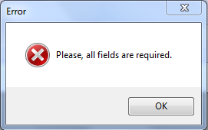

When you press Tab key in Project Name system send cursor to Delivery PM field instead X-GBS PM. When you filled out the X-GBS and press Tab key it goes to

If I flag 3 Regions, then it will be global too.

Message when saving needs to be changed to: “Do you want to create the project?”

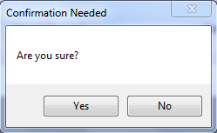

We don’t have here all resources created in the DB

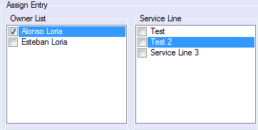 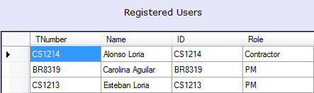

Cancel icon is confused, we need one that will represent better “Clear Filter”

Monthly value needs to appear in blank, for them to know that it needs to be filled out

Project Phase & entry type should be included within outcome data

Name, service line, pp, et, value…

Remove icon functionality? What happened if I have selected some data and system when I press add created some lines, when I press remove does the system needs to remove all entries created?

When I press add without all data(ex without service line), system didn’t show me an error and it’s “showing” entries as outcome data in blank:

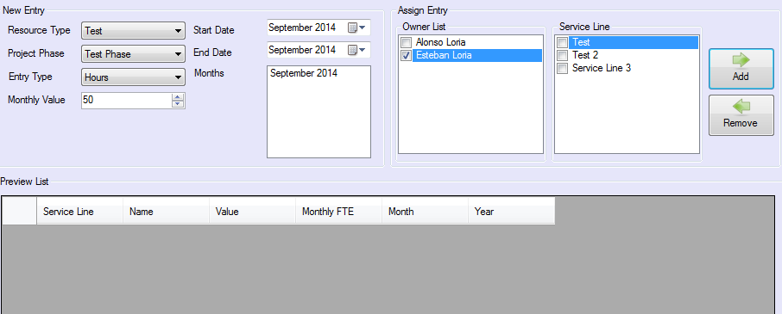

When saving error message needs to change to “Are you sure you want to include this resource(s)?”

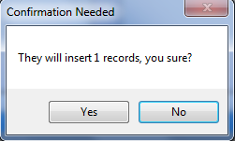

In the screen of resources I’m not sure if icons are reflecting the action, remove filter is filtering and cancel filter is removing all filters

Use clear filter as excel icon

When you press Remove resources, message needs to say “Are you sure you want to delete this resource?”

Delete only future

Edit current and future

“This resource cannot be modified since the due date is in the past”

When creating the project, edit forecast needs to be unavailable, when project is saved, forecast can be edited. Forecast for months in the past can’t be edited.

I changed the forecast from 70 to 3 but system still with 70 as number:



Cancel button needs to be activated only if person change something, doesn’t it?

Clear data

When project is saved, info needs to disappear from screen, if person wants to edit it, they will go to search.

Actuals can’t be tested since I wasn’t able to add any value there

Comments “Vacation / Holiday” in daily entry

Check actual monthly fte sum all fte

“Comment field is mandatory when Value is equal to zero, please fill it out”

Reports

If I put a range, then system needs to showed me both measures per month

Graphic name is missing

Graphic type still simple, we need to look for something more attractive to the eyes

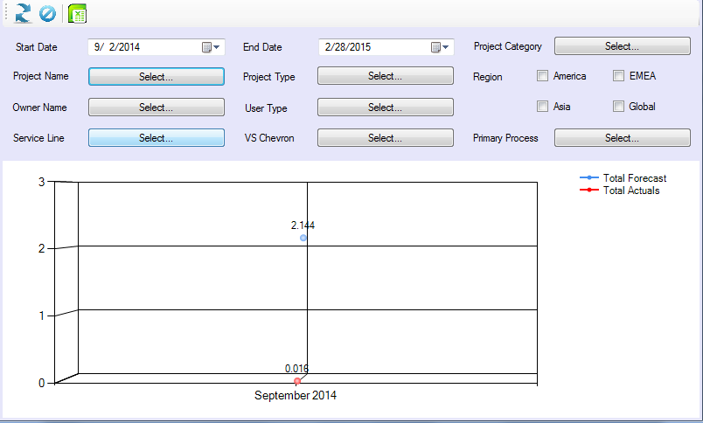

I press Alonso Loria as Owner and system didn’t show me anything:

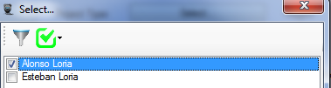

If I make a filter I need to see soething different than select… and if you go to the field again, you need to see data selected

Text in button

If you want to select a primary process, system didn’t need to ask for category or value stream chevron selection, that will need to come for default and by the way they are not even close if technically talking we need to make it like this.

When I export to excel system didn’t allow me to:

